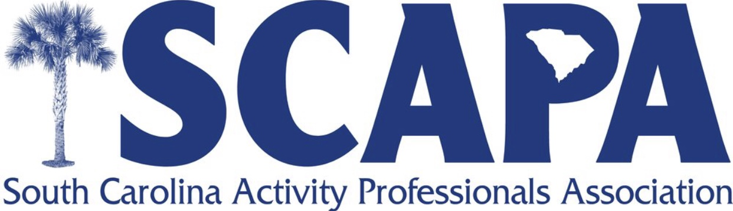
Central District Fall Workshop 2018
Friday, October 26th
1pm-4pm
The Presbyterian Community of Columbia
700 Davega Drive
Lexington, SC 29073
1pm Nutritional Wellness, You and Your Residents-Chef Chris Farney and Jackie Dixon, Dietician
2pm Dancing for Wellness- Renada Weathersbee, Life Enrichment Director at the Crossing-Wear comfortable clothes.
2:30pm-3:30pm An Out of the Box View of The 7 Dimensions of Wellness- Jenny Prather Director of Wellness at the Presbyterian Community of Columbia
3:30pm-4:00pm What is Wellness Wednesday? Try it All Together-Jenny Prather, Amy McCormack and Chef Chris Farney

This workshop will earn you 3 CE hours accepted by NAAPCC, NCCAP, and NCCDP. It is FREE to members and $35 for non-members.
RSVP Amy McCormack, ADC (Central District Rep) by Monday, October 22nd.
amy.mccormack@preshomesc.org or 803-227-8931

